Web Design Project – Paula Olariu

X17370023

Leonid Afremov Solo Art Exhibition

This website was created for a Solo Art Exhibition which will take place at the National Gallery of Copenhagen, Denmark. This Solo Art Exhibition will only display painting created by one person, Leonid Afremov, and will only take please for a single day in April the 15th in 2019. Leonid Afremov is a Contemporary Impressionist with a unique oil painting style.

The “About” page of this website contains information about the art gallery and, about the painter. There are also some pictures taken from different art galleries shown on the about page which when hovered upon zoom in.

The “Paintings” page is mainly focusing on his painting methods but also on the message and feelings he sets to deliver to his audience and art appreciators. There is also a slideshow changing its image every five seconds and is displaying some of Leonid’s most famous works of art.

The “Contact” page is the last page of my website, it contains general information about the art gallery, such as address and contact number. At the end of the page a contact form can be found for the users who wish to get in contact with the exhibition organiser.

References:

* https://www.w3schools.com/howto/howto_css_zoom_hover.asp
* <https://www.w3schools.com/howto/howto_css_responsive_form.asp>
* <https://www.w3schools.com/css/css_navbar.asp>

Link to deployed website:

* https://leonid-afremov-art-exhibition.000webhostapp.com

Wireframe:

|  |
| --- |
| title  Navigation bar |

|  |
| --- |
| Gallery: enlarge when hover  Information about the exhibition  About |

|  |
| --- |
| Slideshow containing some paintings  Information about the paintings  painting |

|  |
| --- |
| Contact Form  Gallery information  Background picture  Contact |

Website Validation:

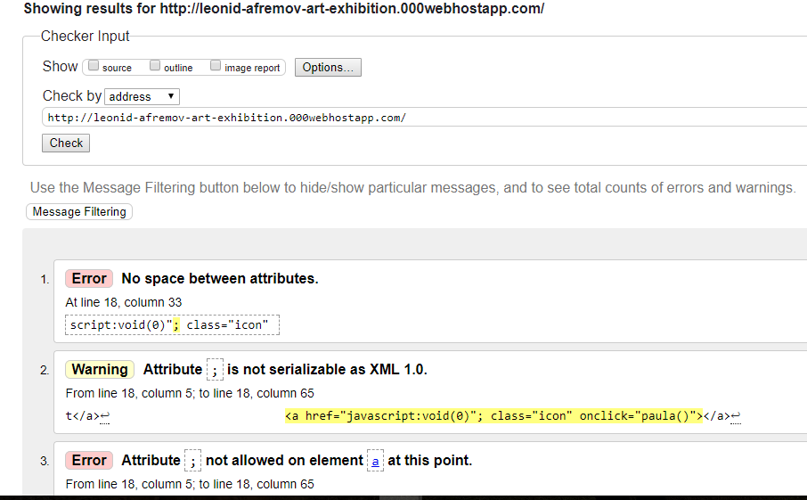

CSS Validation:

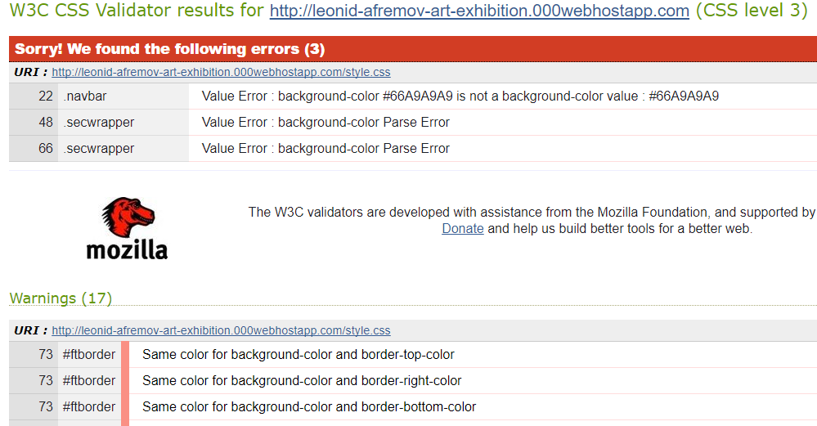

Speed Optimization:



